STUDY SHEET: UNIT 6- TRIGONOMETRY

TOPIC 1: BASIC TRIG
  - PYTHAGOREAN THEOREM: $a^{2}+b^{2}=c^{2}$
    - TRIPPLES:
    - 3,4,5
    - 5,12,13
    - 8,15,17 and any multiple of these triples. Ex: 6-8-10
    - 7,24,25

  - SOHCAHTOA
    - DEGREE MODE!!!!!
    - To find angles, you must use 2nd
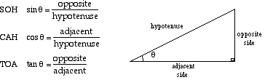

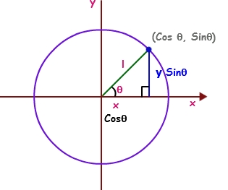
  - THE UNIT CIRCLE
    - Radius = 1; Center = (0, 0)
    - If the circle is in standard form the initial ray will lie on the x-axis and the terminal side will rotate however many degrees counter clockwise A line from the terminal ray should be drawn to the x-axis so we have a right triangle
    - Using the diagram to the right we know that …
        - Sin Ɵ = y
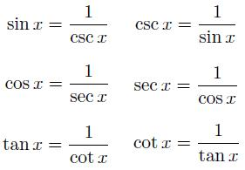
        - Cos Ɵ = x
        - Therefore, (x,y)= (cos Ɵ, sin Ɵ)
        - Tan Ɵ = $\frac{y}{x}$ or $\frac{sinƟ}{cosƟ}$

- RECIPROCAL TRIG FUNCTIONS
  - Secant is reciprocal to Cosine
  - Cosecant is reciprocal to Sine
  - Cotangent is reciprocal to tangent
    - Cotangent can also be expressed as $\frac{cosƟ}{sinƟ}$
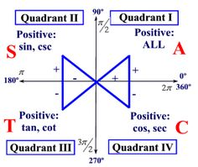
  - When given the one of the trig functions, you simply have to
flip the fraction in order to find its reciprocal
- ASTC
  - Tells you where each trig function is POSITIVE!
  - If a trig function is not positive in a quadrant, that means it is NEGATIVE!
All Star Trig Class

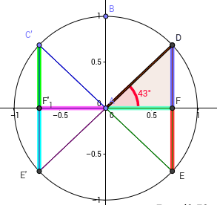
- BOWTIE PROBLEMS
  - STEPS:
- Use ASTC to determine what quadrant you are in
- Draw appropriate triangle
- Label sides of triangle according to SOHCAHTOA
- Use Pythagorean theorem to find missing side
- Solve for desired trig function

- TRIGONOMETRIC IDENTITES
QUOTIENT IDENTIES | RECIPROCAL IDENTITES | PYTHAGOREAN IDENTITES
$$tanθ=\frac{sinθ}{cosθ}$$ | $$cscθ=\frac{1}{sinθ}$$ | $$\sin^{2}{θ+\cos^{2}{θ=1}}$$
$$cotθ=\frac{cosθ}{sinθ}$$ | $$secθ=\frac{1}{cosθ}$$ | $$1-\sin^{2}{θ=\cos^{2}{θ}}$$
 | $$cotθ=\frac{1}{tanθ}$$ | $$1-\cos^{2}{θ=\sin^{2}{θ}}$$
 |  | $$1+\tan^{2}{θ=\sec^{2}{θ}}$$
 |  | $$1+\cot^{2}{θ=\csc^{2}{θ}}$$

- RADIANS
  - Radian: the measure of a central angle that intercepts an arc that is equal in length to the radius of a circle
    - 1 radian= about 57º
    - 360 degrees= about 6.28 radians= 2π

To convert radians to degrees you multiply by $\frac{180}{π}$

To convert degrees to radians you multiply by $\frac{π}{180}$
(DR POT!)

