Lesson 1: The Special Role of Zero in factoring
- Multiplicity- the number of times that a root of an equation occurs; if there is a double-root (mult. of 2), the graph will hit the x-axis and bounce back
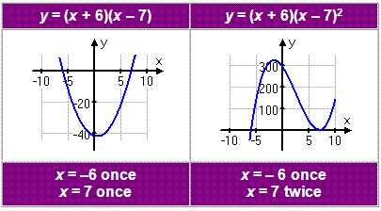

1) f(x)=(x²-9)(x²-16)
- Find the zeros
- State their multiplicities
- State the degree of the polynomial

a) Find the factors: (x+3)(x-3)(x+4)(x-4) and set them equal to zero: x+3=0 x=-3, x—3=0 x=3, x+4=0 x=-4, x-4=0 x=4

b) multiplicity of 1

c) degree is 4 because x²*x²=x⁴

2) Given the roots {4, -5, 0} create an equation *need equal sign*
(x-4)(x+5)(x) -distribute/use tabular method x²+5x-4x-20(x)= x²+x-20(x)= Answer: x³+x²-20x=0

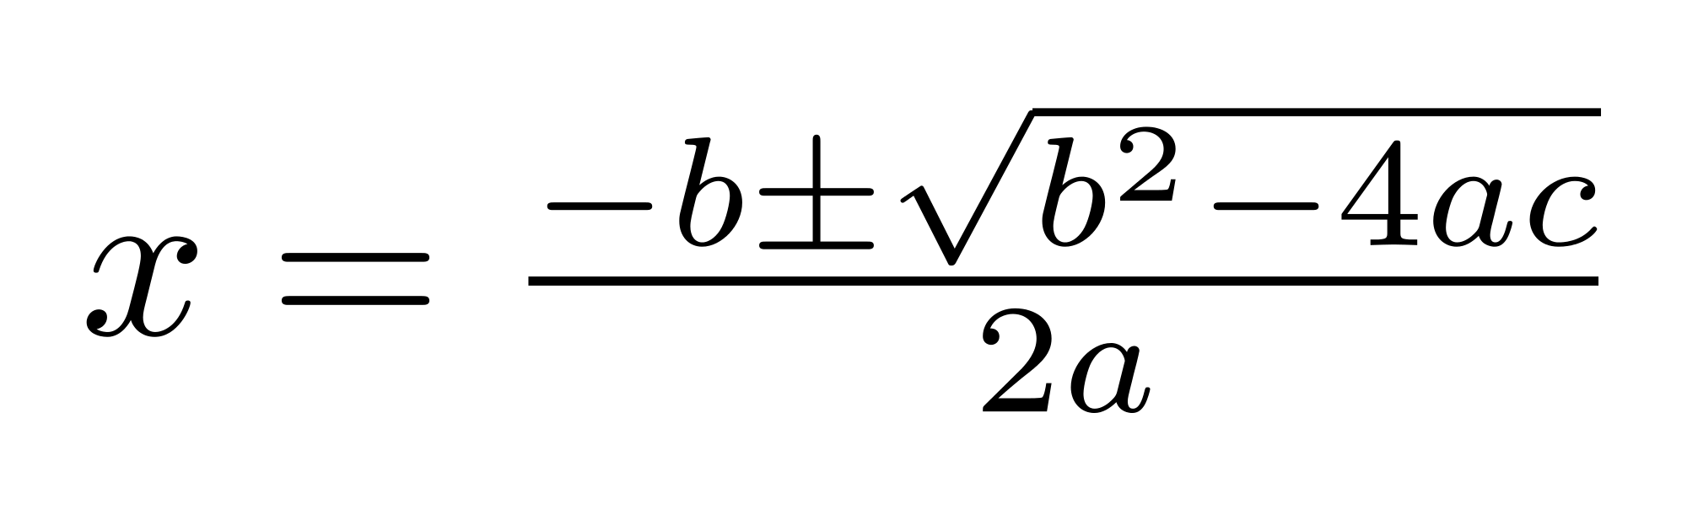
Lesson 2: Using the Quadratic Formula
*Equation must be in y=ax²+bx+c form*

- Find the zeros in simplest radical form of x² - 4x - 1=y
-(-4) ± √(-4)²-4(1)(-1)
x= 2(1)
4± √16+4
x= 2
4±√20
x= 2
4± 2√5
x= 2
Answer: x= 2± 2√5

Lesson 3: Completing the Square
Steps: *always check for a GCF first*
- The a-value must equal 1.
- Move the constant (c-value) to the right side.
- Make the left side a perfect square trinomial (Take half of the b-value and square it) and add it to BOTH sides.
- Factor the perfect square trinomial and simplify the right side.
- Take the square root of both sides and solve! (Remember POSITIVE AND NEGATIVE results!!!!!)

Find the roots in simplest radical form for x²+8x-4=0.
+4 +4
*Bring c-term over- x²+8x=4
b=8 (8/2)²= (4)²=16
x²+8x+[16]=4+[16]
Factor: (x+4)²=20
Take square root of each side: √(x+4)²=√20
x+4=±2√5
-4 -4 Answer: x=-4±2√5

Lesson 4: End Behavior of Polynomial Functions
Function | Even/Odd Degree | Positive/Negative Leading Coefficient | Rise/Fall to the left | Rise/Fall to the right
f(x)=2x²-3x+3 | Even | Positive | Rise | Rise
f(x)=-x⁴+x³-x²+3 | Even | Negative | Fall | Fall
f(x)=x⁵+x³-x+6 | Odd | Positive | Fall | Rise
f(x)=-x³-x-4 | Odd | Negative | Rise | Fall

End behavior:
  - even degree- left and right end behavior is the same
  - odd degree- left and right end behavior is different
- Find the end behavior of f(x)=x⁴-4x³+3x+25
Degree: 4 (even) Leading coefficient: +1 (+) End behavior: Rise, Rise
- Find the end behavior of f(x)=-4x⁴+5x⁵+x²
*put into standard form first: -5x⁵-4x⁴+x²
Degree: 5 (odd) Leading coefficient: -5 (--) End behavior: Rise, Fall

Lesson 5: Even/Odd Functions
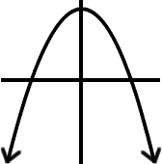
- We use the term Even function (“Equal”) when a function f satisfies the equation f(-x)=f(x) for every number x in its domain. (When you plug –x in, you will get back to the original equation.)
1. Consider the graph of f(x)=-3x²+7
- Evaluate f(-x)
f(-x)=-3(-x)²+7= -3x²+7
b. Is f an even function? Explain how you know.
Yes because f(-x)=f(x)
- We use the term Odd function (“Opposite”) when a function f satisfies the equation f(-x)=-f(x) for every number x in its domain.

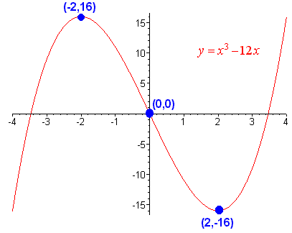
- Consider the graph of f(x)= x³-12x
- Evaluate f(-x)
f(-x)=(-x)³-12(-x)=-x³+12x
- Is f an even function? Explain how you know.
No because f(-x)=-f(x).
- In general, an EVEN function has the following properties:
  - Its graph is symmetric about the y-axis.
  - The exponents of all terms in the equation are even and there can be constants.
- In general, an ODD function has the following properties:
  - Its graph is symmetric about the origin.
  - The y-intercept is zero.
  - The exponents of all terms in its equation are odd and there can be no constant.

Lesson 6: The Relationship Between Multiplicity and the Graph of a Function
- The multiplicity of a root determines whether each graph crosses the x-axis at that zero or if it “bounces” off the root in the direction from which it came.
- When the multiplicity is EVEN, the graph will bounce at the root.
- When the multiplicity is ODD, the graph will go through at the root.

- Given the function, f(x)=-2x(x+5)²(x-3)(x-6)(x-3), WITHOUT A CALCULATOR
- State the degree of the function. 6
- State the roots of the function and their multiplicity.
Root Mult.
0 1
-5 2
3 2
6 1
- State the y-intercept of the function. 0
- Describe the end behavior of the function. Fall, Fall

Lesson 7: Modeling with Polynomials
- Roller coasters are fun! How cool is this real life application!?

Lesson 8: Long Division with Remainders
Remainder
Divisor
- Answer= Quotient +
- Find the quotient of
2x+2
x+2)2x²+6x+5
-(2x²+4x)
1
x+2
2x+5 Answer: 2x+2+
-(2x+4)
1
- Is 2x-5 a factor of 4x³+5x-8?
2x²+5x+15
2x-5) 4x³+0x²+5x-8 *Don’t forget the missing term*
-(4x³-10x²)
-10x²+5x Answer: No b/c there is a remainder of 67
-(-10x²-25x)
30x-8
-(30x-75)
67

- If the remainder is zero, the divisor is a factor of the dividend.
- If there is a remainder, the divisor is not a factor of the dividend.

Lesson 9: The Remainder Theorem

- The remainder found after dividing P by x-a will be the same value as P(a)
- If P(a)= 0, then (x-a) is a factor of P

- Use the remainder theorem to find the remainder of the following
(x²+3x+1)
(x+2) x=-2
f(-2)=(-2)²+3(-2)+1 = 4-6+1
Answer: f(-2)=-1 (x+2) is not a factor because the remainder is -1

- When x³+kx²-4x+2 is divided by x+2, the reminder is 26. Find k.
26= (-2)³+k(-2)²-4(-2)+2
26= -8+4k+8+2
26=4k+2
-2 -2
24=4k Answer: k=6
4 4

