STUDY SHEET: UNIT 4- SYSTEMS AND PARABOLAS
TOPIC #1: SYSTEMS OF EQUATIONS (2 VARIABLES)
METHOD 1: ELIMINATION | METHOD 2: SUBSTITUTION | METHOD 3: SET Y’S =
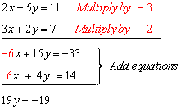 | 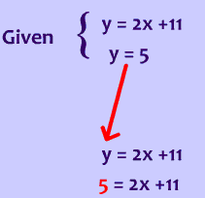 | 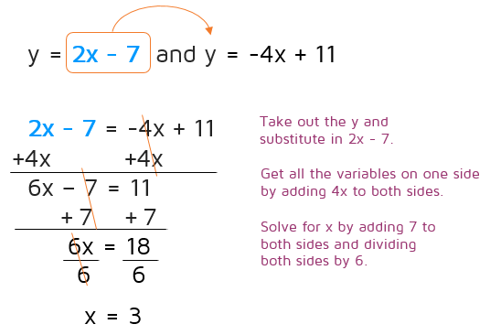

TOPIC #2: SYSTEMS OF EQUATIONS (3 VARIABLES)
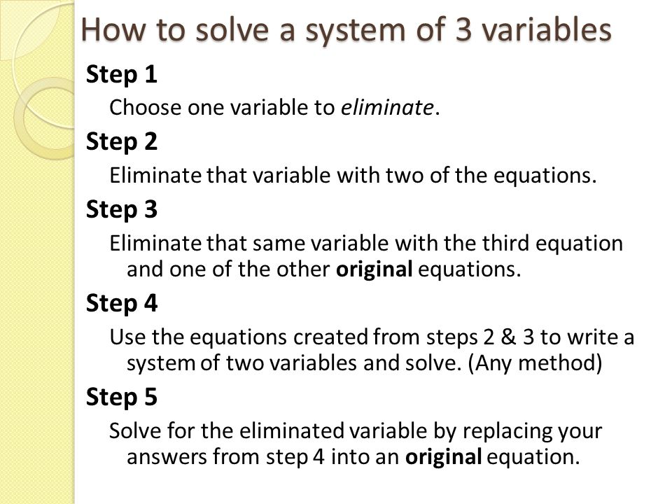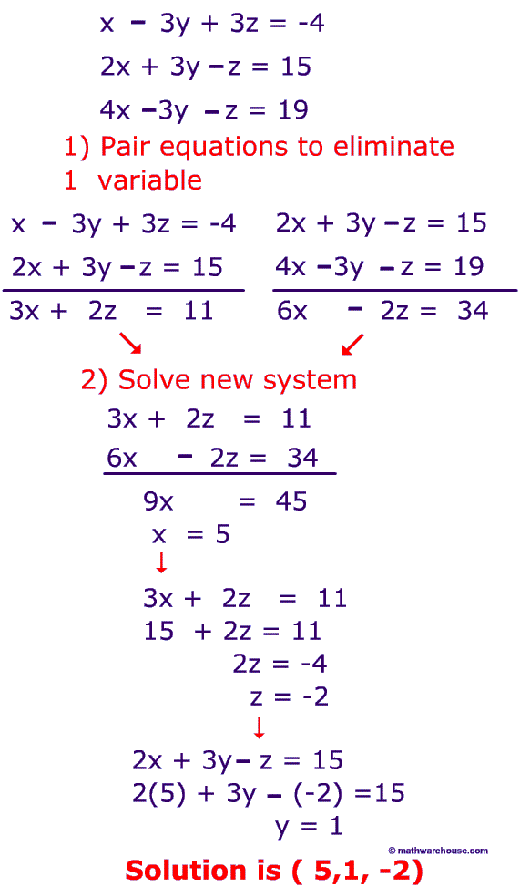

TOPIC #3: CIRCLE AND LINE SYSTEMS
EQUATION OF A CIRCLE BASICS | STEPS: SOLVING LINEAR AND CIRCLE SYSTEMS ALGEBRAICALLY
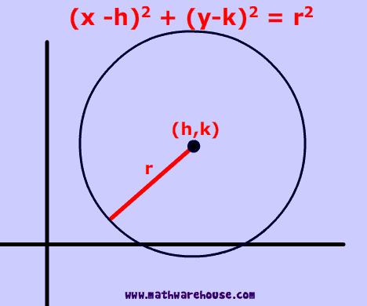  - Flip both signs for h and k when finding the center  - Always take the square root to find the radius!  - When the equation of a circle is in standard form- use completing the square to convert to center-radius form!  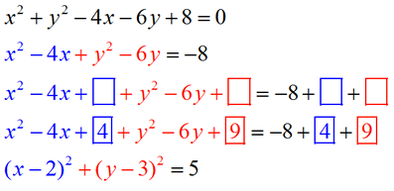 | - Systems of linear equations and circles can have 3 possible outcomes:  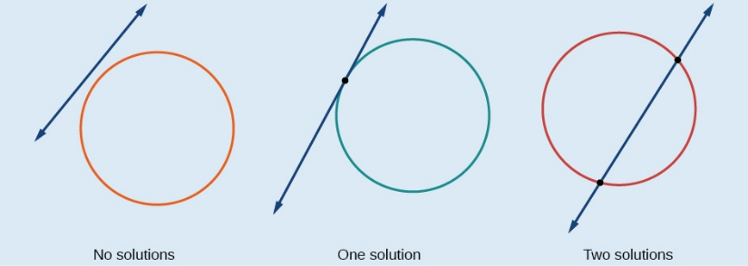  - Convert linear equation to slope-intercept form: $y=mx+b$  - Substitute y in the equation of a circle  - DOUBLE DISTRIBUTE and combine like terms  - Set equal to zero and factor to solve for x.  - Substitute x-values back into equation to find corresponding y-values.  - Write your final answer as 2 coordinates  - Check your answers graphically.
TOPIC #4: PARABOLA AND LINE SYSTEMS
- System of linear equations and parabolas can have 3 possible outcomes:
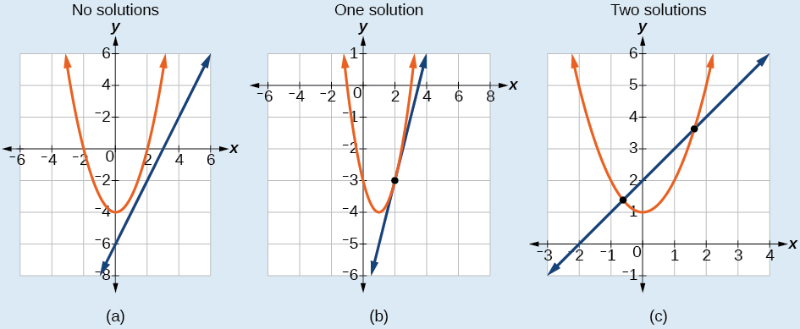
- To solve a linear and parabola system of equations ALGEBRAICALLY:
  - Convert linear equation to slope-intercept form: $y=mx+b$
  - Set equations equal to each other
  - Set equal to zero and factor to solve for x
  - Substitute x-values back into equation to find corresponding y-values.
  - Write your final answer as 2 coordinates
  - Check your answers graphically.

TOPIC #5: PARABOLAS- FOCUS AND DIRECTRIX
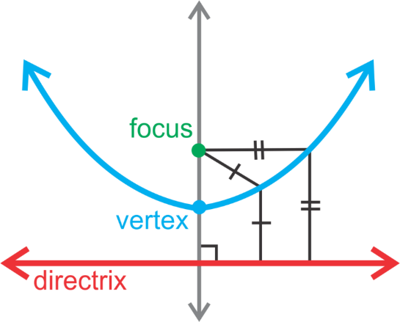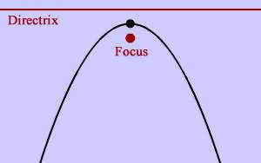
WORD | DEFINITION
Focus | Point INSIDE the parabola
Directrix | Line ABOVE or BELOW the parabola  If directrix is ABOVE the parabola, ‘p’ is NEGATIVE  If directrix is BELOW the parabola, ‘p’ is POSITIVE
Vertex | Turning point of parabola  Midpoint of focus and directrix
Axis of Symmetry | Line that divides the parabola directly in half.  The focus and vertex will fall on this line.

* MEMORIZE THIS FORMULA! *

$$y-k=\frac{1}{2p}{\left(x-h\right)}^{2}$$
$$\left(h, k\right)=Vertex$$
$$p=Distance between Focus and Directrix$$

* When identifying the vertex, only flip the x-coordinate! *

