Name: ____________________________________ Date: __________________________
CC GEOMETRY TROICI
STATION 1: PYTHAGOREAN THEOREM
- The end of a dog's leash is attached to the top of a 5-foot-tall fence post, as shown in the diagram below. The dog is 7 feet away from the base of the fence post.  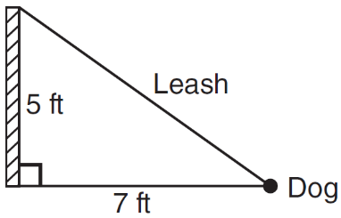  How long is the leash, to the nearest tenth of a foot? | - Campsite A and campsite B are located directly opposite each other on the shores of Lake Omega, as shown in the diagram below. The two campsites form a right triangle with Sam’s position, S. The distance from campsite B to Sam’s position is 1,300 yards, and campsite A is 1,700 yards from his position.  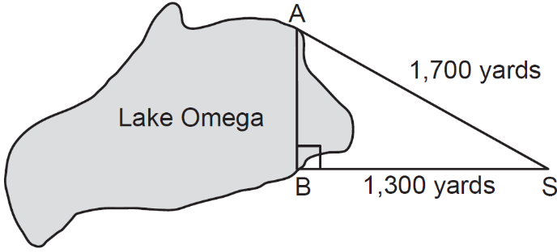  What is the distance from campsite A to campsite B, to the nearest yard?
- The NuFone Communications Company must run a telephone line between two poles at opposite ends of a lake, as shown in the accompanying diagram. The length and width of the lake are 75 feet and 30 feet, respectively.  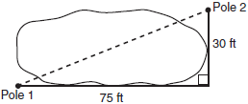  What is the distance between the two poles, to the nearest foot? | - An overhead view of a revolving door is shown in the accompanying diagram. Each panel is 1.5 meters wide.  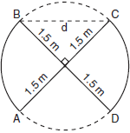  What is the approximate width of d, the opening from B to C?
Name: ____________________________________ Date: __________________________
CC GEOMETRY TROICI
STATION 2: ISOSCELES TRIANGLES
- In the diagram of below, . The measure of is 40°.  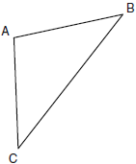  What is the measure of ?  1) 40°  2) 50°  3) 70°  4) 100° | - The accompanying diagram shows the roof of a house that is in the shape of an isosceles triangle. The vertex angle formed at the peak of the roof is 84°.  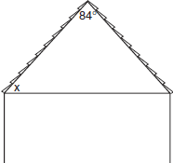  What is the measure of x?  1) 138°  2) 96°  3) 84°  4) 48°
- Tina wants to sew a piece of fabric into a scarf in the shape of an isosceles triangle, as shown in the accompanying diagram.  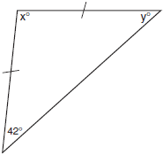  What are the values of x and y?  1)  2)  3)  4) | - In the diagram below of , , , and .  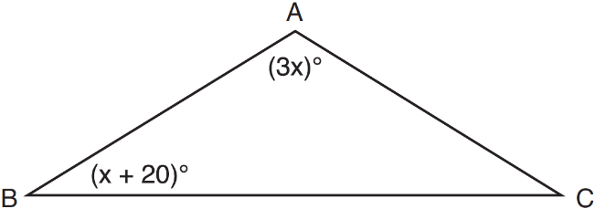  What is the value of x?  1) 10  2) 28  3) 32  4) 40
Name: ____________________________________ Date: __________________________
CC GEOMETRY TROICI
STATION 3: SIMILAR TRIANGLES
- Triangles ABC and DEF are drawn below.  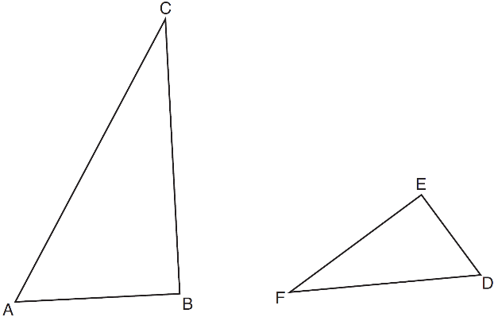  If , , 6, , and , which statement is true?  1)  2)  3)  4) | - The ratio of similarity of to is . If and , then the length of is  1) 5  2) 7  3) 10  4) 20
- In the diagram below, .  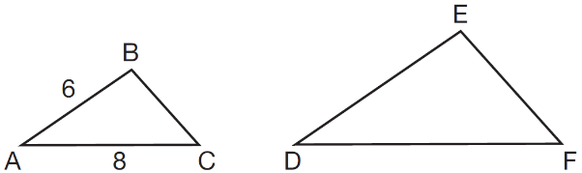  If and , which statement will justify similarity by SAS?  1) , , and  2) , , and  3) , , and  4) , , and | - Using the information given below, which set of triangles can not be proven similar?  1)  2)  3)  4)

Name: ____________________________________ Date: __________________________
CC GEOMETRY TROICI
STATION 4: SIDE-SPLITTER THEOREM
- The accompanying diagram shows two similar triangles.  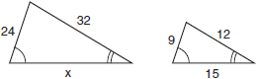  Which proportion could be used to solve for x?  1)  2)  3)  4) | - As shown in the diagram below, , , , , and .  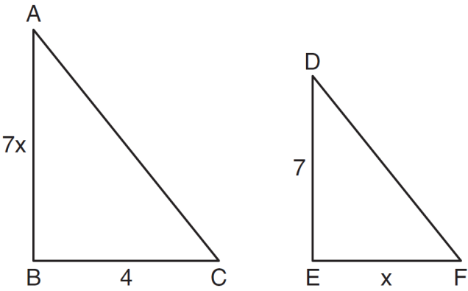  What is the length of ?  1) 28  2) 2  3) 14  4) 4
- In the diagram below of , .  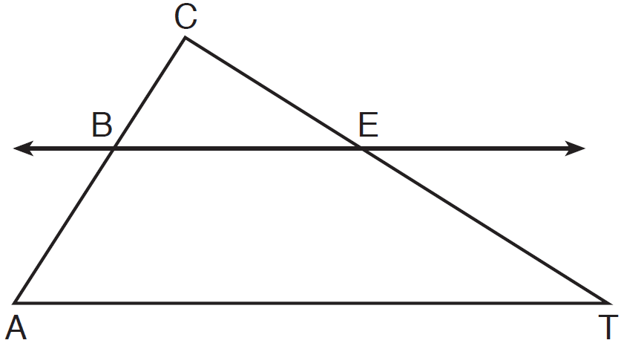  If , , and , what is the length of ?  1) 5  2) 14  3) 20  4) 26 | - In the diagram of below, , , , and .  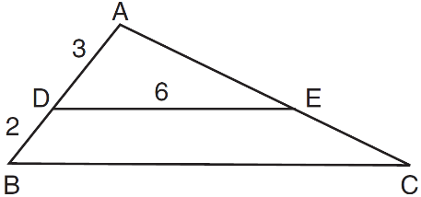  What is the length of ?  1) 12  2) 10  3) 8  4) 4

Name: ____________________________________ Date: __________________________
CC GEOMETRY TROICI
STATION 5: EXTERIOR ANGLE THEOREM
- In the diagram of below, , , and is extended through N.  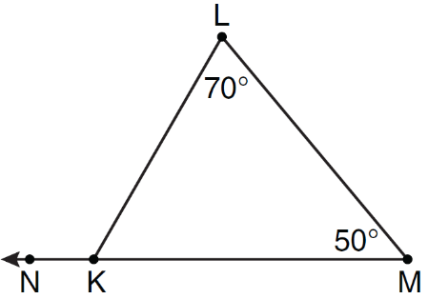  What is the measure of ?  1) 60º  2) 120º  3) 180º  4) 300º | - In the diagram below, and are shown with and .  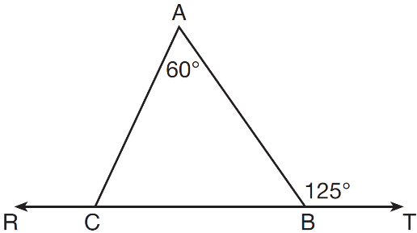  What is ?  1) 125  2) 115  3) 65  4) 55
- In the diagram below of , side is extended to point D, , , and .  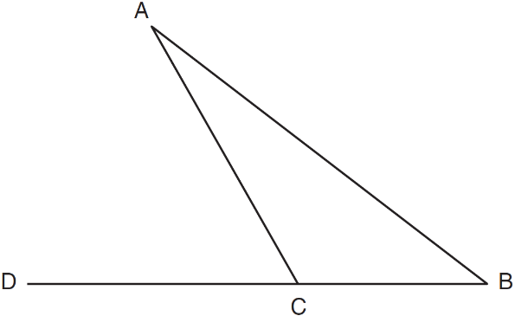  What is ?  1) 5  2) 20  3) 25  4) 55 | - In the diagram of below, is extended to point D.  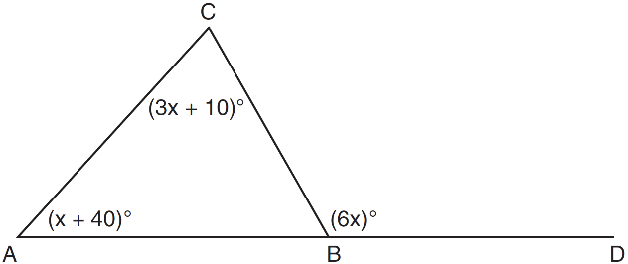  If , , , what is ?  1) 13  2) 25  3) 53  4) 65

