Name: ______________________________ Date: ________________________
CC GEOMETRY TROICI
STATION 1: LINE DILATIONS
1. A line segment is dilated by a scale factor of 2 centered at a point not on the line segment. Which statement regarding the relationship between the given line segment and its image is true?  1) The line segments are perpendicular, and the image is one-half of the length of the given line segment.  2) The line segments are perpendicular, and the image is twice the length of the given line segment.  3) The line segments are parallel, and the image is twice the length of the given line segment.  4) The line segments are parallel, and the image is one-half of the length of the given line segment. | 2. A three-inch line segment is dilated by a scale factor of 6 and centered at its midpoint. What is the length of its image?  1) 9 inches  2) 2 inches  3) 15 inches  4) 18 inches
3. The line is dilated by a scale factor of and centered at the origin. Which equation represents the image of the line after the dilation?  1)  2)  3)  4) | 4. Line n is represented by the equation . Determine and state the equation of line p, the image of line n, after a dilation of scale factor centered at the point . [The use of the set of axes below is optional.] Explain your answer.  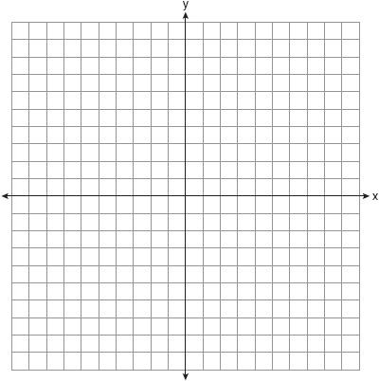
Name: ______________________________ Date: ________________________
CC GEOMETRY TROICI
STATION 2: RIGID MOTIONS
1. What are the coordinates of , the image of , after a rotation of 180º about the origin?  1)  2)  3)  4) | 2. If point is rotated counterclockwise 90° about the origin, its image will be point  1)  2)  3)  4)
3. Point is reflected in the x-axis. In which quadrant does its image lie?  1) I  2) II  3) III  4) IV | 4. On the accompanying set of axes, draw the reflection of ABCD in the y-axis. Label and state the coordinates of the reflected figure.  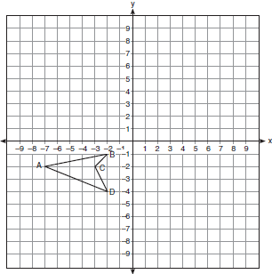
5. Triangle ABC has vertices , , and . Under a translation, , the image point of A, is located at . Under this same translation, point is located at  1)  2)  3)  4) | 6. The image of under a translation is . Under this translation, maps onto . Using this translation, the coordinates of image are . Determine and state the coordinates of point A.

Name: ______________________________ Date: ________________________
CC GEOMETRY TROICI
STATION 3: DILATIONS
- Triangle ABC has coordinates , , and . On the set of axes below, graph and label , the image of after a dilation of 2. | 2. The image of after a dilation of scale factor k centered at point A is , as shown in the diagram below.  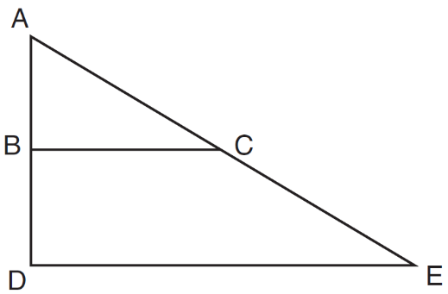  Which statement is always true?  1)  2)  3)  4)
3. Under a dilation where the center of dilation is the origin, the image of is . What are the coordinates of , the image of under the same dilation?  1)  2)  3)  4) | 4. Triangle is the image of under a dilation such that . Triangles and are  1) congruent but not similar  2) similar but not congruent  3) both congruent and similar  4) neither congruent nor similar
5. The point maps onto under a dilation with respect to the origin. What is the scale factor?  1)  2)  3) 3  4) | 6. What is the image of point after a dilation with the center at the origin and a scale factor of 4?

Name: ______________________________ Date: ________________________
CC GEOMETRY TROICI
STATION 4: COMPOSITION OF TRANSFORMATIONS
1. The image of under a translation is . Under this translation, maps onto . Using this translation, the coordinates of image are . Determine and state the coordinates of point A.  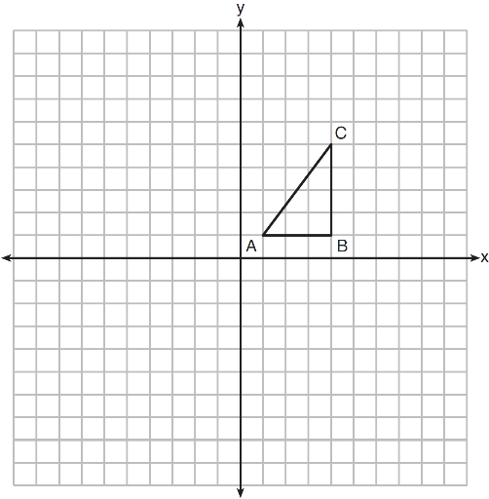 | 2. The coordinates of , shown on the graph below, are , , and . Graph and label , the image of after it is reflected over the y-axis. Graph and label , the image of after it is reflected over the x-axis. State a single transformation that will map onto .  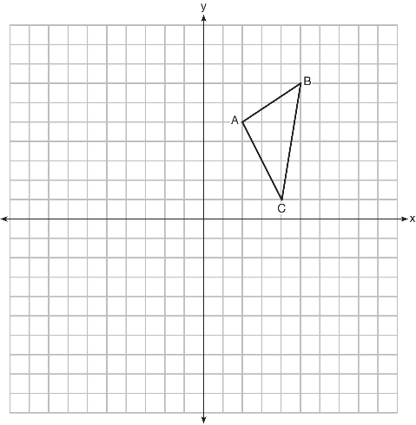
I 3. In the diagram below, is a transformation of , and is a transformation of .  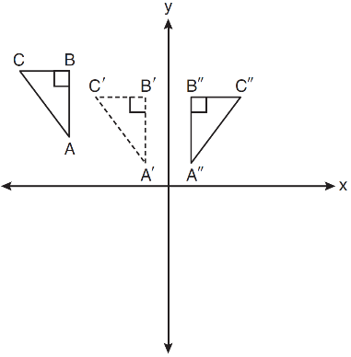  The composite transformation of to is an example of a  1) reflection followed by a rotation  2) reflection followed by a translation  3) translation followed by a rotation  4) translation followed by a reflection | 4. The graph below shows and its image, .  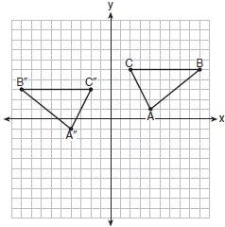  Describe a sequence of rigid motions which would map onto .

Name: ______________________________ Date: ________________________
CC GEOMETRY TROICI
STATION 5: MAPPING A POLYGON ONTO ITSELF
1. If a pentagon is rotated clockwise around its center, the minimum number of degrees it must be rotated to carry the pentagon onto itself is  1) 54º  2) 72º  3) 108º  4) 360º | 2. Which regular polygon has a minimum rotation of 45° to carry the polygon onto itself?  1) octagon  2) decagon  3) hexagon  4) pentagon
3. Which rotation about its center will carry a regular decagon onto itself?  1) 54°  2) 162°  3) 198°  4) 252° | 4. Which figure always has exactly four lines of reflection that map the figure onto itself?  1) square  2) rectangle  3) regular octagon  4) equilateral triangle
I 5. In the diagram below, a square is graphed in the coordinate plane.  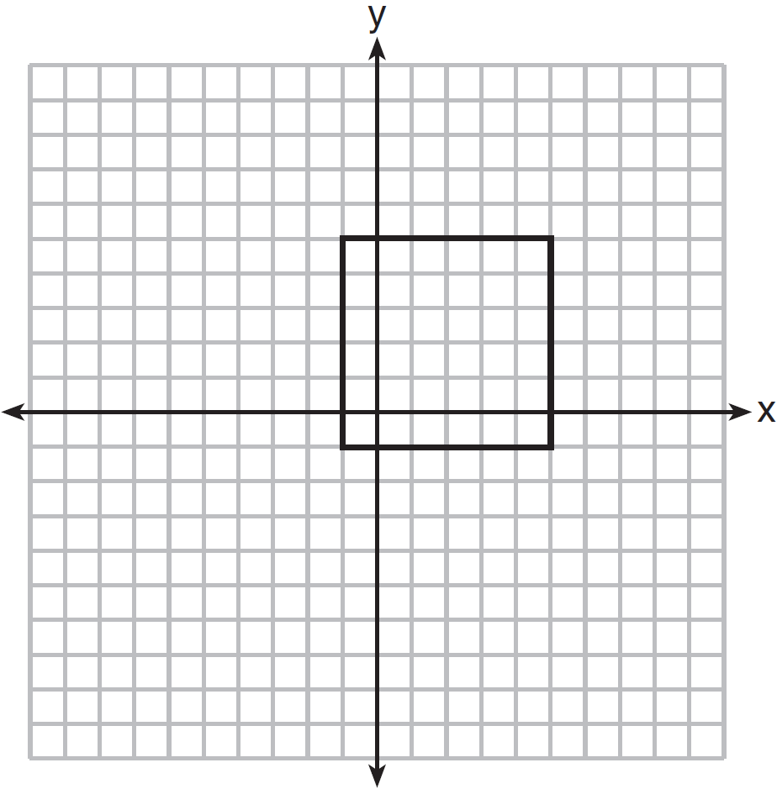  A reflection over which line does not carry the square onto itself?  1)  2)  3)  4) | 6. A regular hexagon is rotated in a counterclockwise direction about its center. Determine and state the minimum number of degrees in the rotation such that the hexagon will coincide with itself.

