Name: ___________________________ Date: _____________________
CC GEOMETRY TROICI
MINI-LESSON #9: TRANSFORMATIONS
TOPIC 1: TYPES OF TRANSFORMATION
 | KEY WORD | RIGID MOTION? | DIRECT/OPPOSITE ISOMETRY | IMAGE
REFLECTION |  |  |  | 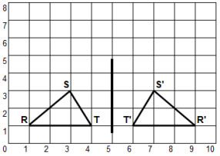
ROTATION
TRANSLATION |  |  |  | 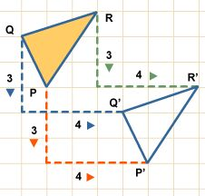
DILATION |  |  |  | 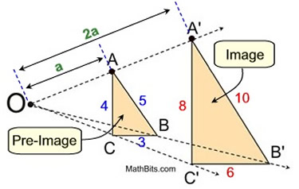
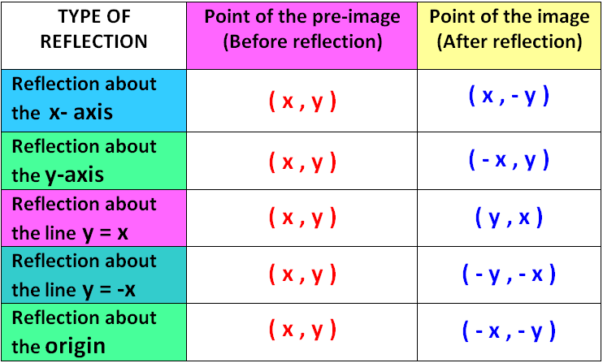
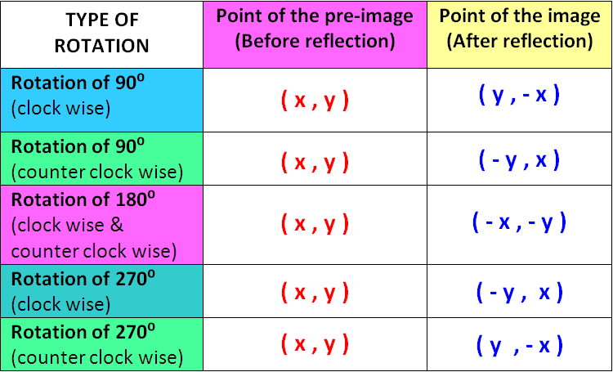
RULES FOR ROTATIONS AND REFLECTIONS:
TOPIC 2: LINE DILATIONS
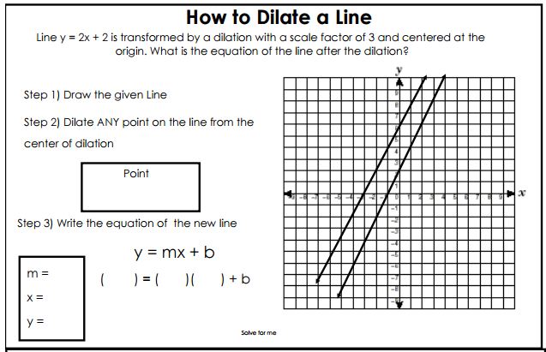
TOPIC 3: MAPPING A REGULAR POLYGON ONTO ITSELF
Definition: Regular Polygon
________________________________________________________________________________________________
When a polygon is rotated onto itself, it rotated by a multiple of the exterior angles in a polygon.
SHAPE | NUMBER OF SIDES | DEGREES OF EXTERIOR ANGLE
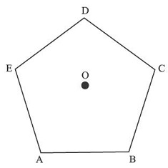
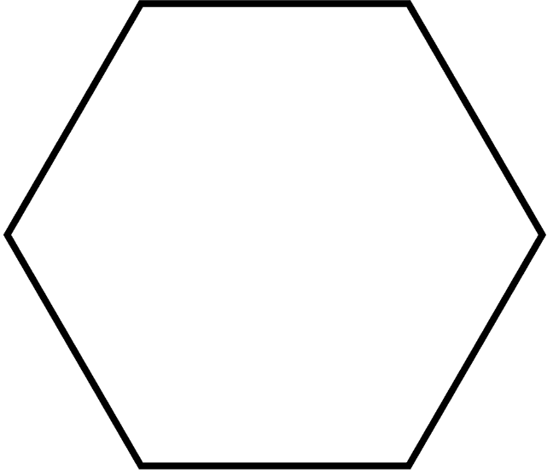
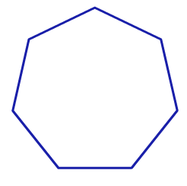
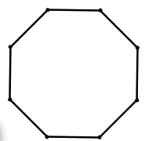
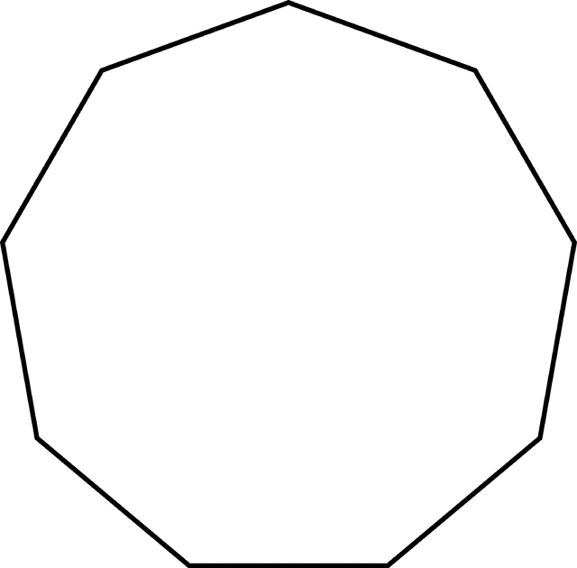

TOPIC 4: COMPOSITION OF TRANSFORMATIONS
COMPOSITOIN OF RIGID MOTIONS | SIMILARITY TRANSFORMATION
