Name: ___________________________ Date: ____________________
CC GEOMETRY TROICI
MINI-LESSON #10: TRIANGLE PROOFS
TOPIC 1: TRIANGLE CONGRUENCE PROOFS
STEPS TO WRITING A FORMAL PROOF:
- Mark up your diagram using the given information
  - Match your tick marks on sides with congruent sides and angles with congruent angles
- Make a plan
  - Identify what method you are using (HL, SSS, SAS, ASA, AAS) with the information you are given
- Create your Statement/Reason columns
  - #1 is always your “Given” information
- Be sure to write a statement and reason for all three pieces needed to prove triangles congruent
- The last statement is your congruence statement (BE CAREFUL WITH CORRESPONDING PIECES) followed by your method (HL, SSS, SAS, ASA, AAS)
- After you have proved two triangles are congruent, you can prove that corresponding parts of congruent triangles are congruent. You may abbreviate with CPCTC.

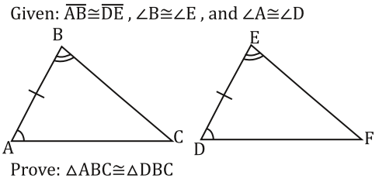
Fill in the blanks for the following formal proofs:
- PLAN:
HL 1.)
SSS
SAS 2.)
ASA
AAS 3.)

STATEMENT | REASON
1. $\overset{̿}{AB} ≅\overset{̿}{DE}$  $<A≅<D$  $<B≅<E$ | 1. Given
2. | 2.
What rigid motion maps $∆ABC$ onto $∆DEF$?

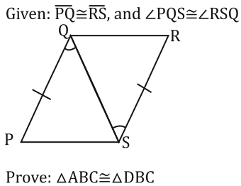
2. PLAN:
HL 1.)
SSS
SAS 2.)
ASA
AAS 3.)

STATEMENT | REASON
1. $\overset{̿}{PQ} ≅\overset{̿}{RS}$  $<PQS≅<RSQ$ | 1.
2. | 2. Reflexive Property
3. $∆PQS≅∆RSQ$ | 3.
What rigid motion maps $∆PQS$ onto $∆RSQ$?

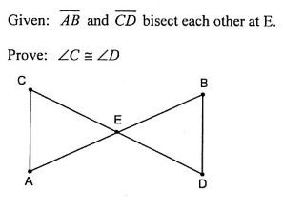
3. PLAN:
HL 1.)
SSS
SAS 2.)
ASA
AAS 3.)

4.)

TOPIC 2: TRIANGLE SIMILARITY PROOFS
STEPS TO WRITING A FORMAL PROOF:
- Mark up your diagram using the given information
  - Match your tick marks on sides with congruent sides and angles with congruent angles
- Make a plan
  - The only method used in similarity proofs is AA
- Create your Statement/Reason columns
  - #1 is always your “Given” information
- Be sure to write a statement and reason for the two corresponding angles you are proving congruent
- The last statement is your similarity statement (BE CAREFUL WITH CORRESPONDING PIECES) followed by your method (AA)
- After you have proved two triangles are similar you can prove that corresponding sides of similar triangles are in proportion.
- After you have proved sides are in proportion, you can prove that the product of the means equals the product of the extremes.
EXAMPLE 1:
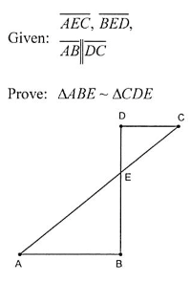

EXAMPLE 2:
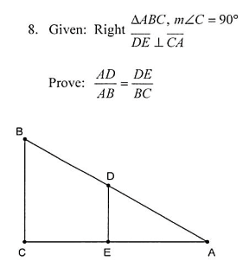

EXAMPLE 3:
