Name: ___________________ Date: ______________
CC GEOMETRY TROICI
MINI-LESSON #6: SOLID GEOMETRY
DEFINITIONS
WORD | DEFINITION | IMAGE
Solid Figure |  | 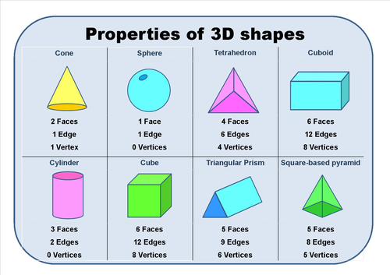
Cross Section
Area |  | 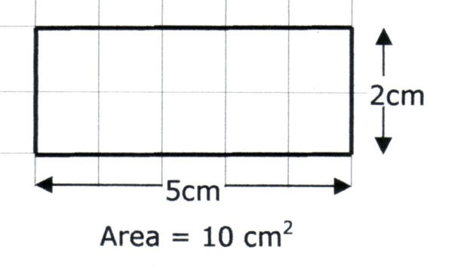
Surface Area |  | 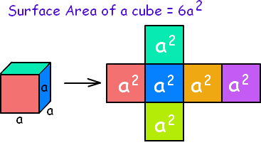
Volume |  | 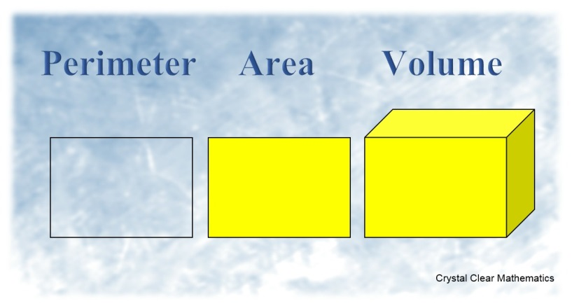
Height |  | 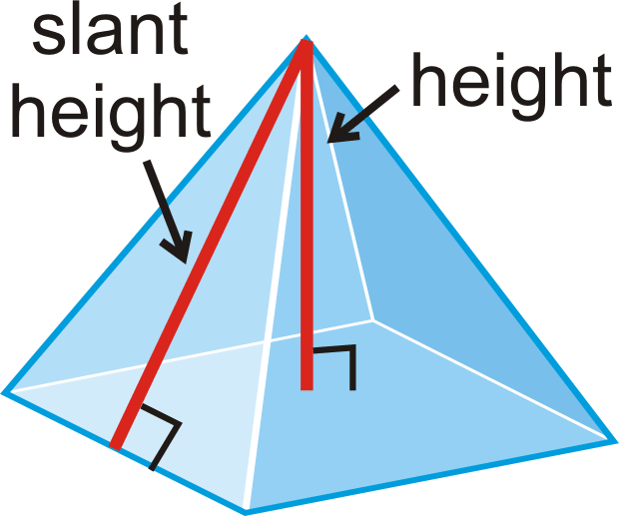
Slant Height |  | 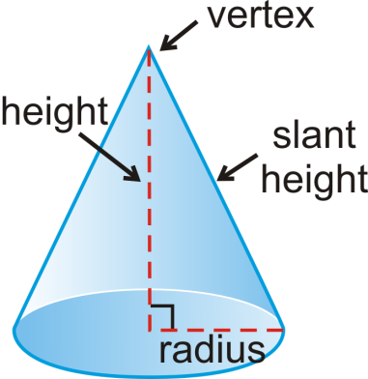
Density |  | 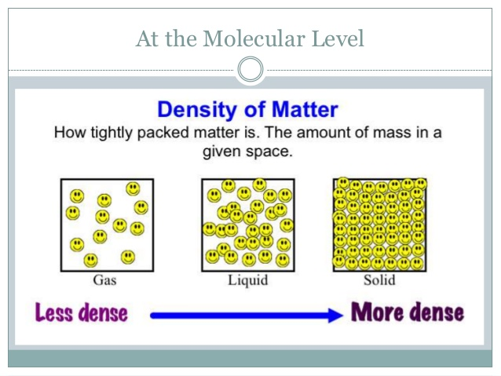
Population Density |  | 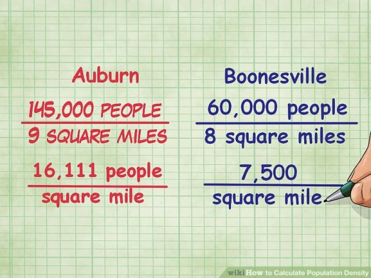
FORMULAS
WHAT YOU NEED TO KNOW | WHAT IS GIVEN TO YOU
- Area of a Rectangle/Square =  - SA of a Rectangular Prism =  - SA of a Cylinder =  - SA of a Sphere =  - SA of a Cone =  - SA of a Pyramid =  - Density =  - Population Density = | - Area of a Triangle = $\frac{1}{2}bh$  - Area of a Parallelogram = $bh$  - Area of a Circle = $πr^{2}$  - Circumference of a Circle = $πd or 2πr$  - Volume of General Prisms = $Bh$  - Volume of a Cylinder = $πr^{2}h$  - Volume of a Sphere = $\frac{4}{3}πr^{3}$  - Volume of a Cone = $\frac{1}{3}πr^{2}h$  - Volume of a Pyramid = $\frac{1}{3}Bh$  - Pythagorean Theorem = $a^{2}+b^{2}=c^{2}$

NOTATION
LETTER | MEANING
B
$$l$$
$$w$$
$$h$$
$$l$$
$$r$$
$$C$$
$$A$$
$$V$$

TOPIC 1: CROSS SECTIONS
1 The cross section of a regular pyramid contains the altitude of the pyramid. The shape of this cross section is a  1) circle  2) square  3) triangle  4) rectangle | 2 Which figure can have the same cross section as a sphere?  1)  2)  3)  4)
3 If t If the rectangle below is continuously rotated about side w, which solid figure is formed?  1) pyramid  2) rectangular prism  3) cone  4) cylinder | 4 Which object is formed when right triangle RST shown below is rotated around leg ?  1) a pyramid with a square base  2) an isosceles triangle  3) a right triangle  4) a cone

TOPIC 2: VOLUME
1 In the diagram below, a right circular cone has a diameter of 8 inches and a height of 12 inches.  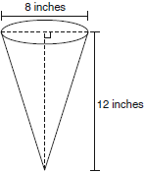  What is the volume of the cone to the nearest cubic inch?  1) 201  2) 481  3) 603  4) 804 | 4 A block of wood is 5 inches long, 2 inches wide, and 3 inches high. What is the volume of this block of wood?  1)  2)  3)  4)
The di  The diameter of a sphere is 15 inches. What is the volume of the sphere, to the nearest tenth of a cubic inch?  1) 706.9  2) 1767.1  3) 2827.4  4) 14,137.2 | A pac A packing carton in the shape of a triangular prism is shown in the diagram below.  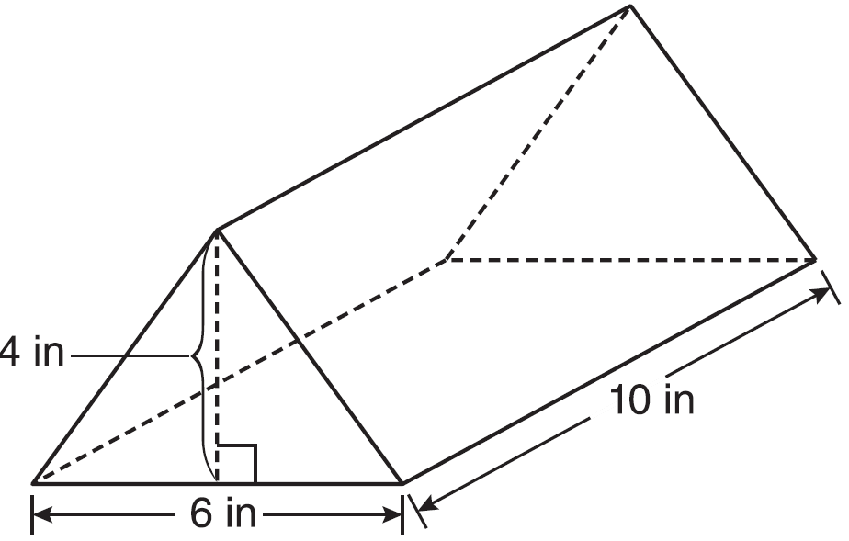  What is the volume, in cubic inches, of this carton?  1) 20  2) 60  3) 120  4) 240
A re A regular pyramid has a height of 12 centimeters and a square base. If the volume of the pyramid is 256 cubic centimeters, how many centimeters are in the length of one side of its base?  1) 8  2) 16  3) 32  4) 64 | The v The volume of a cylindrical can in cubic inches. If the height of the can is 2 inches, what is its radius, in inches?  1) 8  2) 2  3) 16  4) 4
TOPIC 3: SURFACE AREA
The r The rectangular prism shown below has a length of 3.0 cm, a width of 2.2 cm, and a height of 7.5 cm.  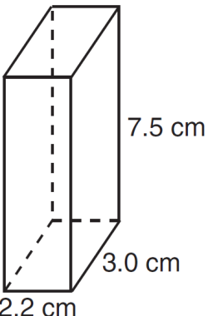  What is the surface area, in square centimeters?  1) 45.6  2) 49.5  3) 78.0  4) 91.2 | The b The base of a closed right circular cylinder has a diameter of 5 cm. If the height of the cylinder is 8 cm, what is the surface area of the cylinder, to the nearest square centimeter?  1) 157  2) 165  3) 408  4) 628
Find the surface area of the sphere below: | Find the surface area of the cone below:

TOPIC 4: DENSITY
The d The density of the American white oak tree is 752 kilograms per cubic meter. If the trunk of an American white oak tree has a circumference of 4.5 meters and the height of the trunk is 8 meters, what is the approximate number of kilograms of the trunk?  1) 13  2) 9694  3) 13,536  4) 30,456 | Molly Molloy wishes to make a lawn ornament in the form of a solid sphere. The clay being used to make the sphere weighs .075 pound per cubic inch. If the sphere's radius is 4 inches, what is the weight of the sphere, to the nearest pound?  1) 34  2) 20  3) 15  4) 4
A hemispherical tank is filled with water and has a diameter of 10 feet. If water weighs 62.4 pounds per cubic foot, what is the total weight of the water in a full tank, to the nearest pound?  1) 16,336  2) 32,673  3) 130,690  4) 261,381 | A wooden cube has an edge length of 6 centimeters and a mass of 137.8 grams. Determine the density of the cube, to the nearest thousandth. State which type of wood the cube is made of, using the density table below.  