Name: _______________________________ Date: _____________________
CC GEOMETRY TROICI
MINI-LESSON #5: CIRCLES
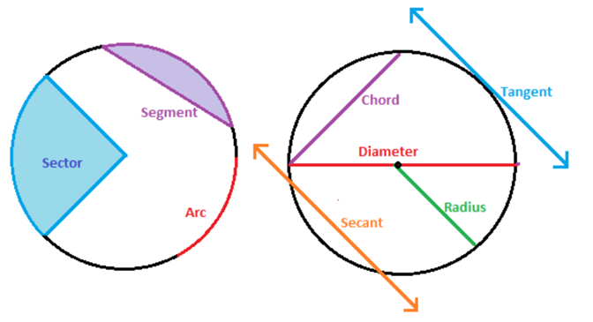
TOPIC 1: AREA AND CIRCUMFERENCE OF A CIRCLE
AREA (INSIDE) | CIRCUMFERENCE (OUTSIDE)
$$A=πr^{2}$$  Derived form: $Half Circumference ×Radius$ | $C=2πr$ OR $C=πd$

TOPIC 2: ARC LENGTH
$$\frac{Arc Length}{2πr}=\frac{Arc Measure}{360}$$
ARC MEASURE | ARC LENGTH
The arc represented in __________________  Compared to _________________________ | The arc represented in _______________________  Compared to the ___________________________

TOPIC 3: SECTOR AREA
$$\frac{Sector Area}{πr^{2}}=\frac{Arc Measure}{360}$$
AREA | SECTOR AREA
The space inside the WHOLE circle | The space inside a section of the circle (PIZZA SLICE!)  Compared to the total __________________

TOPIC 4: ANGLE THEOREMS
- A semi-circle equals ___________ degrees.
- A radian is simply another way to express degrees of an angle. To convert from radians to degrees use the formula below (GIVEN TO YOU ON REGENTS)

$$Degree to Radian=Multiply by \frac{π}{180}$$
- If two angles intercept the same arc then those angles are ________________________
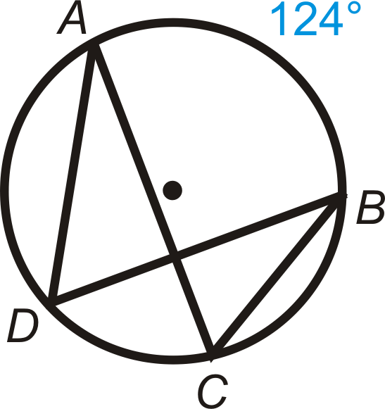
INSCRIBED ANGLES | CENTRAL ANGLES
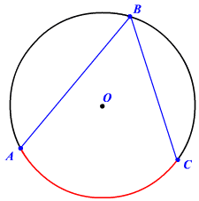 | 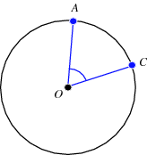
TANGENT-RADIUS | TANGENT-CHORD
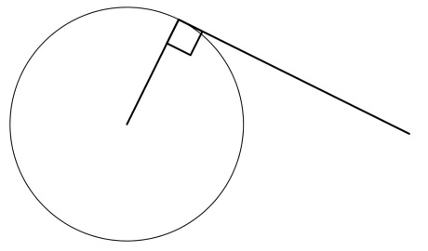 | 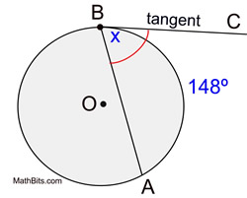
EXTERNAL ANGLE | CHORD CHORD ANGLE
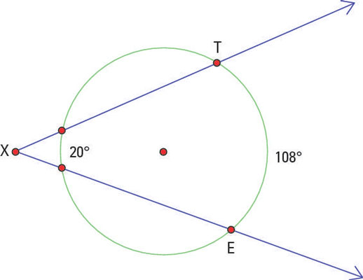 | 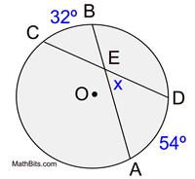

TOPIC 5: SEGMENTS THEOREMS
INTERSECTING CHORDS | SECANT-SECANT FROM EXTERNAL POINT
TANGENT-SECANT | TANGENT-TANGENT
TOPIC 6: EQUATIONS OF CIRCLES
$${\left(x-h\right)}^{2}+{\left(y-k\right)}^{2}=r^{2}$$
Where $(h,k)$ = Center
And $r$ = Radius
- Use completing the square to convert to the form above
  - Example: $x^{2}+y^{2}-4x+8y+11=0$

- To determine if a point lies on the circle, substitute into the equation and see if it yields a true statement.

