Name: __________________________ Date: _____________________
CC GEOMETRY TROICI
MINI-LESSON #3: TRIANGLES
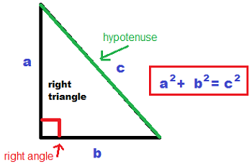
TOPIC 1: PYTHAGOREAN THEOREM
- Only used in _____________ triangles!
- The hypotenuse must always be the _________ value.

TOPIC 2: EXTERIOR ANGLES OF TRIANGLES
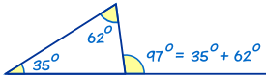
$$Exterior Angle=Sum of Two Non-Adjacent Interior Angles$$

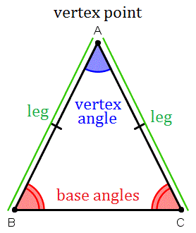
TOPIC 3: ISOSCELES TRIANGLES

- Base angles are _____________________
- Two sides are _______________________

TOPIC 4: MIDSEGMENTS OF TRIANGLES
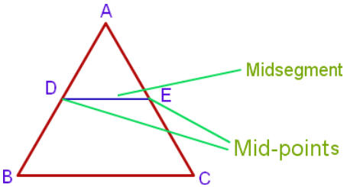
- The midsegment is created by connecting two
___________________ of opposite sides in a triangle.
- The midsegment is exactly __________________ of the
opposite side.
- The midsegment is _________________ to the opposite side.

TOPIC 5: CONGRUENT TRIANGLES
5 METHODS TO PROVE TRIANGLES CONGRUENT
- In congruent triangles all sides of one triangle are ______________ to all the sides of another triangle
- In congruent triangles all angles of one triangle are _____________ to all the angles of another triangle.
- You only need 3 pieces of information to prove that all the sides and angles of a triangle are congruent. The 3 variations are our triangle congruence postulates listed below:
SSS | SAS | ASA | AAS | HL
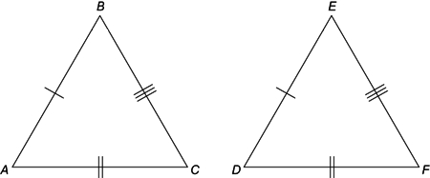 | 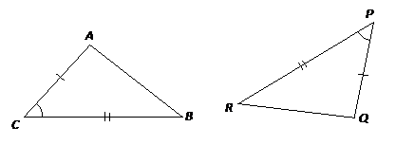 | 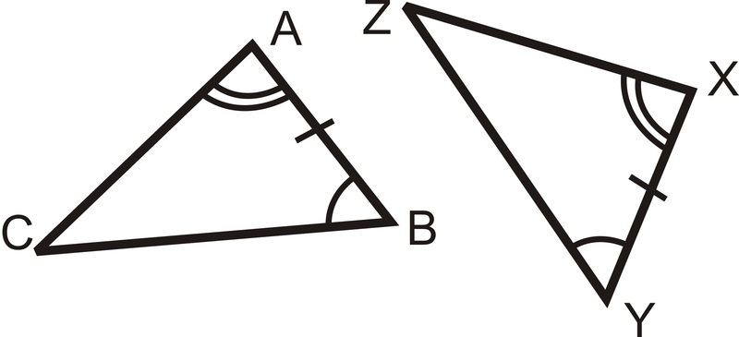 | 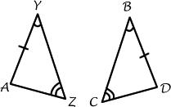 | 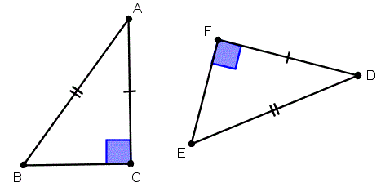

METHODS YOU CANNOT USE TO PROVE TRIANGLES CONGRUENT
SSA | AAA
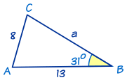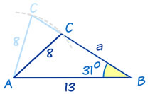 | 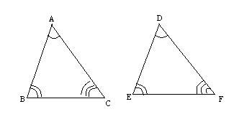

TOPIC 6: SIMILAR TRIANGLES
3 METHODS TO PROVE TRIANGLES ARE SIMILAR
- When two triangles are similar they are the same __________________ but different __________________.
- Angles of similar triangles are _______________________.
- *Sides of similar triangles are _____________________________.* (NOT CONGRUENT!)
- Sides of similar triangles will share the same _______________________ ___________________.
- Scale factors when a triangle goes from small to big are ___________________________.
- Scale factors when a triangle goes from big to small are ___________________________.
- You can prove triangles are similar by proving angles are congruent or if the sides share the same ratio. These are our similarity postulates listed below:
AA$≅$ | SAS$\sim$ | SSS$\sim$
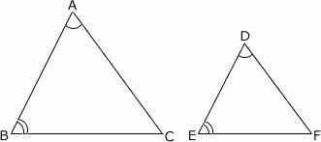 | 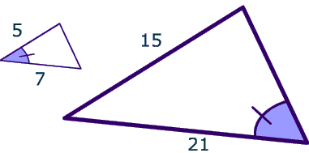 | 