Name: ______________________________ Date: ___________________________
CC GEOMETRY TROICI
TASK CARD #1: TRIANGLE CONGRUENCE

In the diagram of and below, , , and .

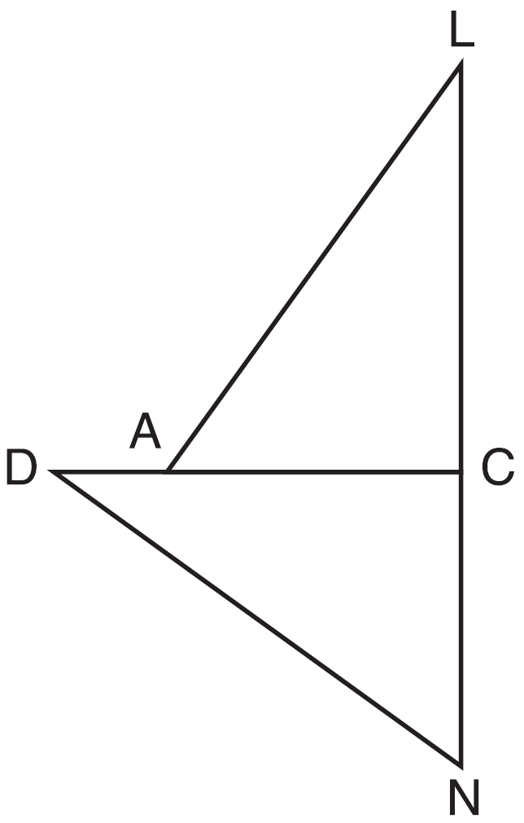

a) Prove that .

b) Describe a sequence of rigid motions that will map onto :

Name: ______________________________ Date: ___________________________
CC GEOMETRY TROICI
TASK CARD #2: TRIANGLE SIMILARITY

In the accompanying diagram, and and intersect at point T.

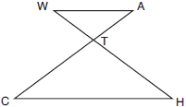
Prove that: $\frac{WT}{TH}=\frac{AT}{CT}$

Name: ______________________________ Date: ___________________________
CC GEOMETRY TROICI
TASK CARD #3: QUADRILATERAL PROOF
Given: JKLM is a parallelogram.

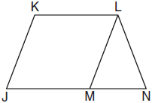
Prove: JKLM is a rhombus.

Name: ______________________________ Date: ___________________________
CC GEOMETRY TROICI
TASK CARD #4: CIRCLE PROOF

Given: Chords and of circle O intersect at E, an interior point of circle O; chords and are drawn.

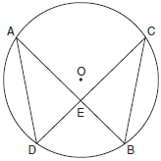

Prove:

