A If you got $42°$, then do:
In below, the measure of , , , and .

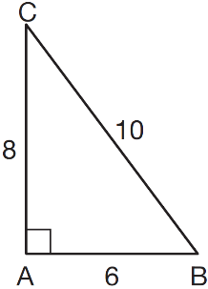

Which ratio represents the sine of ?

B If you got $\frac{8}{10}$, then do:
Which ratio represents the cosine of angle A in the right triangle below?

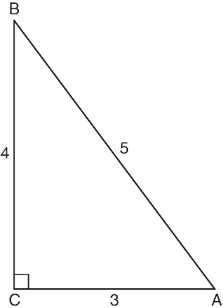

C If you got $\frac{3}{5}$, then do:
The diagram below shows right triangle LMP.

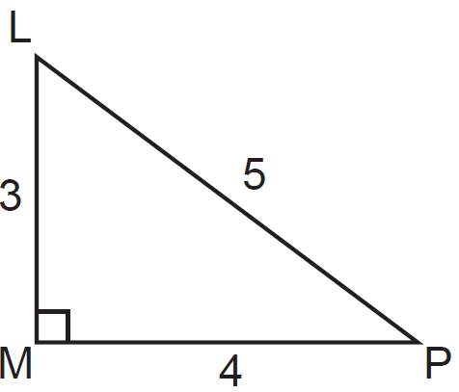

Which ratio represents the tangent of ?

D If you got $\frac{4}{3}$, then do:
In , where is a right angle, 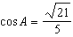. What is ?

E If you got $\frac{\sqrt{21}}{5}$, then do:
If , what is the value of x?

F If you got $x=35$, then do:
In the right triangle shown in the diagram below, what is the value of x to the nearest whole number?

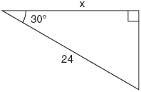

G If you got $x=21$, then do:
The diagram below shows two similar triangles.

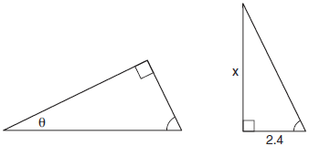

If 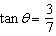, what is the value of x, to the nearest tenth?

H If you got $x=5.6$, then do:
A right triangle contains a 38° angle whose opposite side measures 10 centimeters.
What is the length of the hypotenuse, to the nearest hundredth of a centimeter?

I If you got 16.24, then do:
As shown in the diagram below, the angle of elevation from a point on the ground to the top of the tree is 34°.

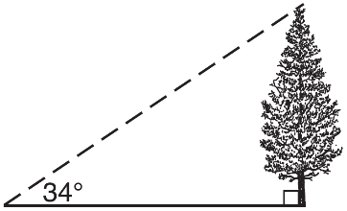

If the point is 20 feet from the base of the tree, what is the height of the tree, to the nearest tenth of a foot?

J If you got 13.5, then do:
In the diagram of right triangle ABC shown below, and .

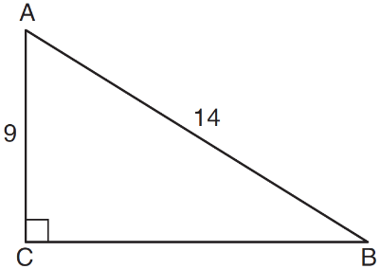

What is the measure of , to the nearest degree?

K If you got $50°$, then do:
The diagram below shows the path a bird flies from the top of a 9.5-foot-tall sunflower to a point on the ground 5 feet from the base of the sunflower.

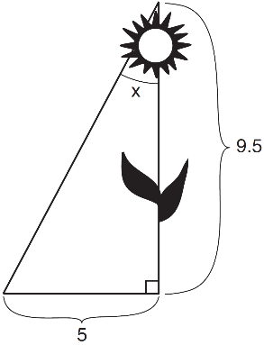

To the nearest tenth of a degree, what is the measure of angle x?

L If you got $27.8°$, then do:
A man who is 5 feet 9 inches tall casts a shadow of 8 feet 6 inches.
Assuming that the man is standing perpendicular to the ground,
what is the angle of elevation from the end of the shadow to the top of the man’s head,
to the nearest tenth of a degree?
(*HINT*: Convert to inches first!)

M If you got $34.1°$, then do:
The center pole of a tent is 8 feet long, and a side of the tent is 12 feet long as shown in the diagram below.

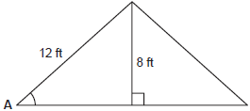

If a right angle is formed where the center pole meets the ground, what is the measure of angle A to the nearest degree?

Name: ____________________________________ Date: __________________________________
CC GEOMETRY TROICI
SCAVENGER HUNT WORKSPACE

A | B
C | D
E | F
G | H
I | J
K | L
M

